Digital Logic Design Lab # 07

# Student Name: Muhammad Ahmed Baig Reg#20i-1884

***Lab Section:B***

### Lab Title:

Half Adder and Full Subtractor

### Objectives:

To become familiar with the operation of adders and Subtractors

### Equipment Required:

* DEV-2765E Trainer Board
* 7486 quad 2-input XOR gate IC
* 7404 Hex Inverter gate IC
* 7408 quad 2-input AND gate IC
* 7432 quad 2-input OR gate IC

### Background Theory

In this lab, we will design arithmetic circuits that are actually combinational circuits. An arithmetic circuit performs arithmetic operations such as addition, multiplication, subtraction, and division with binary numbers or with decimal numbers in a binary code. Adder/subtractor is a very important component of digital system, ALU and Processor (CPU). A combinational circuit that performs the addition of two bits is called half adder. The circuit of half adder has two outputs, one sum(s) and other carry (c). For multi bit addition the carry obtained from the addition of two least significant bits is added to the next higher order pair of significant bits. A combinational circuit that performs the subtraction of two bits is called half subtractor. One that performs the subtraction of three bits (two significant bits and a previous carry) is called full subtractor. The circuits of half and full subtractor have two outputs, one subtraction and other borrow.

The input-output logical relationship of the full-adder/subtractor circuit may be expressed in two Boolean functions, one for each output variable. Each output Boolean function requires a unique map for its simplification. Each map must have eight squares, since each output is a function of three input variables.

**HALF ADDER**

### Truth Table:

|  |  |  |  |
| --- | --- | --- | --- |
| **Input** | | **Output** | |
| **A** | **B** | **Sum** | **Carry** |
| 0 | 0 | 0 | 0 |
| 0 | 1 | 1 | 0 |
| 1 | 0 | 1 | 0 |
| 1 | 1 | 0 | 1 |

***K-MAP:***

***Sum***

|  |  |  |
| --- | --- | --- |
| ***a\b*** | ***0*** | ***1*** |
| ***0*** | *0* | *1* |
| ***1*** | *1* | *0* |

***Count***

|  |  |  |
| --- | --- | --- |
| ***a\b*** | ***0*** | ***1*** |
| ***0*** | *0* | *0* |
| ***1*** | *0* | *1* |

***Boolean Functions of Output:***

Sum =A**⊕B** Carry

=A.B

### Circuit Diagram:

Implement circuit on Proteus and label the output of all gates

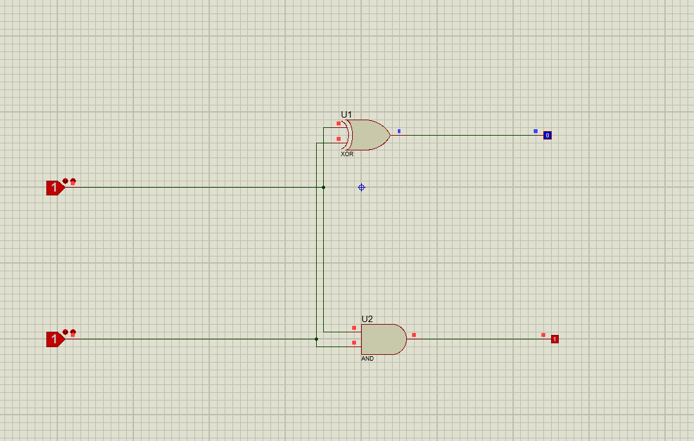

## FULL SUBTRACTOR

### Truth Table:

|  |  |  |  |  |
| --- | --- | --- | --- | --- |
| **Input** | | | **Output** | |
| **A** | **B** | **B_in** | **Difference** | **B_out** |
| 0 | 0 | 0 | 0 | 0 |
| 0 | 0 | 1 | 1 | 1 |
| 0 | 1 | 0 | 1 | 1 |
| 0 | 1 | 1 | 0 | 1 |
| 1 | 0 | 0 | 1 | 0 |
| 1 | 0 | 1 | 0 | 0 |
| 1 | 1 | 0 | 0 | 0 |
| 1 | 1 | 1 | 1 | 1 |

***K-MAP:***

***Difference***

|  |  |  |  |  |
| --- | --- | --- | --- | --- |
| ***B_in/AB*** | ***00*** | ***01*** | ***11*** | ***10*** |
| ***0*** | *0* | *1* | *0* | *1* |
| ***1*** | *1* | *0* | *1* | *0* |

***B_out***

|  |  |  |  |  |
| --- | --- | --- | --- | --- |
| ***a\b*** | ***00*** | ***01*** | ***11*** | ***10*** |
| ***0*** | *0* | *1* | *1* | *1* |
| ***1*** | *0* | *0* | *1* | *0* |

***Boolean Functions of Output:***

Difference =

(A **⊕** B ) **⊕** B_in

B_out =

B. B_in + A’.B + A’. B_in

### Circuit Diagram:

Implement circuit on Proteus and label the output of all gates

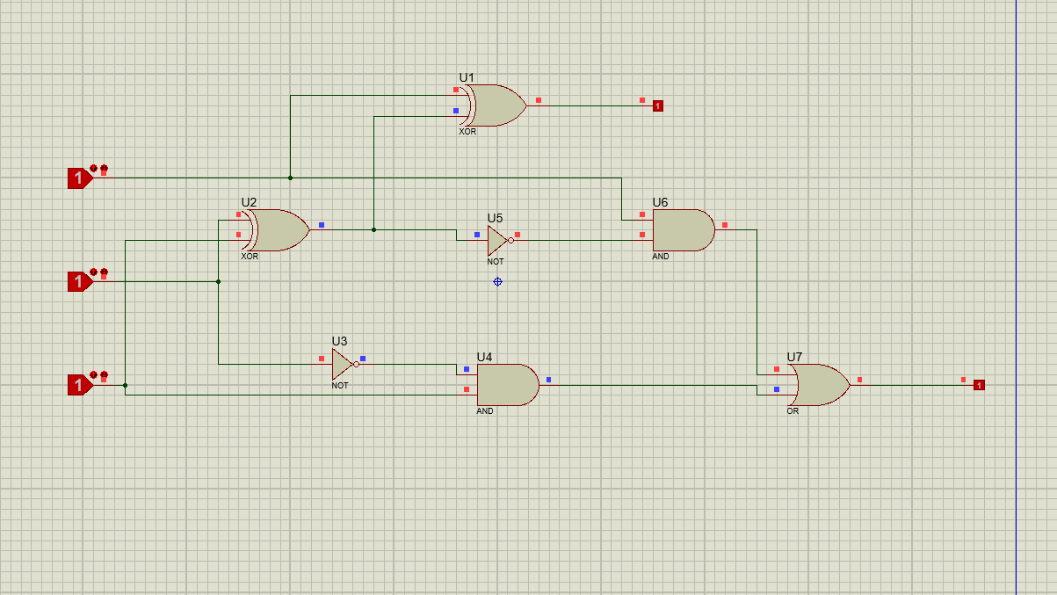

### Procedure

1. Connect the trainer with the power supply
2. Install the IC 74LS32 and 74LS04 on the trainer board
3. Wire according to the diagram.
4. Use the logic switches for input and connect output of Half Adder (Sum and Carry) and Full Subtractor (Difference and B_out) to the LEDs of trainer board.
5. Supply the VCC and GND to the pin 14 and 7 respectively 6. Test all the possible combination of inputs and fill out the table.